Additional Exercises #7

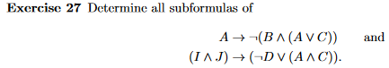

A, B, C, (A ⋁ C), ( B ∧ (A ⋁ C) ), ㄱ( B ∧ (A ⋁ C) ), also the original formula

I, J, A, C, D, ∧ J, (ㄱD) , (A ∧ C) , (ㄱD ⋁ (A ∧ C) ), also the original formula



